Guided Capstone Project

# Step 1 – install azure-cli (mac) as shown here .

>brew update && brew install azure-cli

# Step 2 – installation complete

# Step 3 – log into azure portal



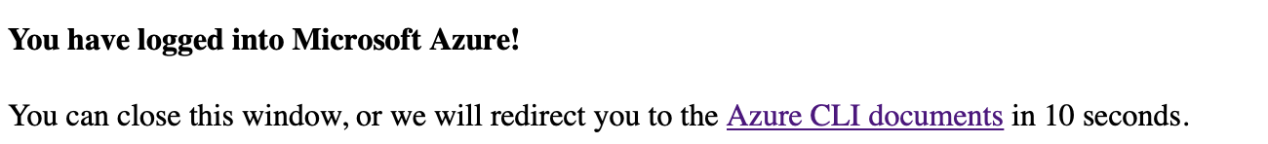

# Step 4 -

Download Mac version azcopy utility from [link](https://docs.microsoft.com/en-us/azure/storage/common/storage-use-azcopy-v10) and place it in Guided Capstone folder.

Azcopy download from here: <https://docs.microsoft.com/en-us/azure/storage/common/storage-use-azcopy-v10>

# Step 5 - Run the following command for azcopy login with tenant id credentials. You can get tenant id from azure portal.



# Step 6 – copy the code from previous step



# Step 7 – run azcopy command to copy files from local to storage account container. Create container in azure portal if required.

Run azcopy command : highlighted in yellow.

>Guided Capstone Project % ./azcopy copy "/Users/greenbook/Desktop/springboard/Guided Capstone Project/data/" "https://springcapital.blob.core.windows.net/springcapital" --recursive=true

# Step 8 -

View the copied files in azure portal storage account container.

# Step 9 - create azure databricks workspace and spin a cluster, follow the steps below. Accept defaults.

# Step 10 – start a new notebook. auth using crendentials for storage acct, access key, and blob container , as shown below. Mount the volume. . And follow the instructions and code from the notebook committed to git repository.

Follow the instructions in the attached notebook

# Step 11

Delete created resources and cleanup azure account so you don’t incur additional charges.

